**ECO3702: Advanced Macroeconomics Lecture Note 6.**

2018

**Flexible Price IS – LM Model with Phillips Curve**

**Kaan Öğüt**

Bahçeşehirunıversıty

1. **Flexible Price IS – LM Model with Phillips Curve**

This section is based on the aggregate demand-supply model augmented with adaptive expectations of Scarth (1988), which he calls as the ‘flexible price IS-LM model’. In this model, aggregate price level and expected inflation are included into the standard model as new dynamic variables Income and interest rate may also be defined as dynamic variables as in Shone (2002). Hence, by combining Scartch (1988) and Shone (2002), we are able to build a model consists of a system of differential equations with four dynamic variables.

Inflation is described as a percentage change of price of goods.

$$π=\frac{{dP}/{dt}}{P}=\frac{\dot{P}}{P}$$

$$p=\ln{P}→π=\frac{dp}{dt}=\dot{p}$$

According to Phillips rule in equation inflation depends on output gap and its expectations,

$$\dot{p}=π=π^{e}+γ\left(\frac{Y-\overline{Y}}{\overline{Y}}\right) γ>0$$

or it depends on difference of actual unemployment level from its natural.

$$\dot{p}=π=π^{e}-γ\left(u-u_{N}\right) γ>0$$

Expected inflation rate is adjusted according to difference of actual inflation rate and itself

$$\dot{π^{e}}=\frac{dπ^{e}}{dt}=λ\left(π-π^{e}\right)$$

Or like Blanchard, expected inflation can be described as a previous value of actual inflation rate.

$π_{t}^{e}=π_{t-1}$

It is possible to rewrite four variable differential equation system.

$$\dot{Y}=\frac{dY}{dt}=α\left[AD-Y\right]$$

$$\dot{\dot{i}}=\frac{di}{dt}=β\left[M_{D}\left(Y,i\right)-\overline{\frac{M_{S}}{P}}\right]=β\left[L_{D}\left(Y,i\right)-\overline{\frac{M_{S}}{P}} \right]$$

Hence, the **demand for real money balances** depends both on the level of income and on the **nominal interest rate**, we write the general **money demand function like as $M_{D}\left(Y,i\right)$**  or $L_{D}\left(Y,i\right)$ The letter *L* is used to denote money demand because money is the economy’s most liquid asset (the asset most easily used to make transactions). This equation states that the demand for the liquidity of real money balances is a function of income and the nominal interest rate.

While **investment** depends on the **real interest rate**, **money demand** depends on the **nominal interest rate[1]** (Mankiw, 2000, 300; Blanchard, 2011, 297). In fixed price IS – LM model, because of the inflation expectation $π^{e}$ is taken as zero, thereby real $r$ and nominal $i$ interest rates would be same.

$$r=i-π^{e}$$

$$if π^{e}=0 then r=i$$

But flexible price IS – LM Model allows the use real and nominal interest rates together.



**Story of Phillips Curve:**





**Contributions of Samuelson and Solow**



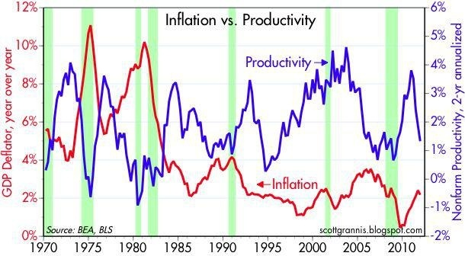







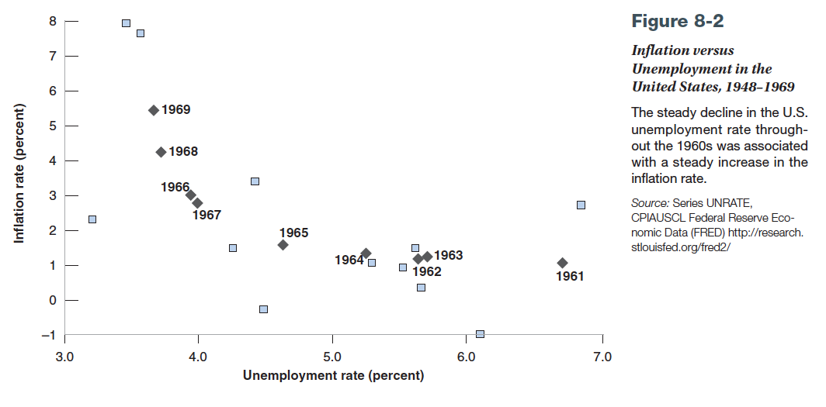

**Contributions of Friedman and Phelps**





















|  |  |  |  |  |
| --- | --- | --- | --- | --- |
| Dependent Variable: CHANGE_IN_INFLATION | | | |  |
| Method: Least Squares | | |  |  |
| Date: 04/09/18 Time: 10:44 | | |  |  |
| Sample: 1981 2018 | | |  |  |
| Included observations: 38 | | |  |  |
|  |  |  |  |  |
|  |  |  |  |  |
| Variable | Coefficient | Std. Error | t-Statistic | Prob. |
|  |  |  |  |  |
|  |  |  |  |  |
| C | 2.239082 | 0.854313 | 2.620915 | 0.0128 |
| UNEMPLOYMENT_RATE | -0.406443 | 0.132354 | -3.070881 | 0.0040 |
|  |  |  |  |  |
|  |  |  |  |  |
| R-squared | 0.207577 | Mean dependent var | | -0.299368 |
| Adjusted R-squared | 0.185566 | S.D. dependent var | | 1.473765 |
| S.E. of regression | 1.330014 | Akaike info criterion | | 3.459452 |
| Sum squared resid | 63.68171 | Schwarz criterion | | 3.545640 |
| Log likelihood | -63.72958 | Hannan-Quinn criter. | | 3.490117 |
| F-statistic | 9.430309 | Durbin-Watson stat | | 1.848393 |
| Prob(F-statistic) | 0.004047 |  |  |  |
|  |  |  |  |  |
|  |  |  |  |  |

|  |  |  |  |  |
| --- | --- | --- | --- | --- |
| Dependent Variable: CHANGE_IN_INFLATION | | | |  |
| Method: Least Squares | | |  |  |
| Date: 04/09/18 Time: 10:48 | | |  |  |
| Sample: 1981 2018 | | |  |  |
| Included observations: 38 | | |  |  |
|  |  |  |  |  |
|  |  |  |  |  |
| Variable | Coefficient | Std. Error | t-Statistic | Prob. |
|  |  |  |  |  |
|  |  |  |  |  |
| C | 0.073812 | 0.260828 | 0.282992 | 0.7788 |
| UNEMPLOYMENT_RATE-NATUREL_RATE_OF_UNEMPLOY | -0.404936 | 0.150183 | -2.696292 | 0.0106 |



















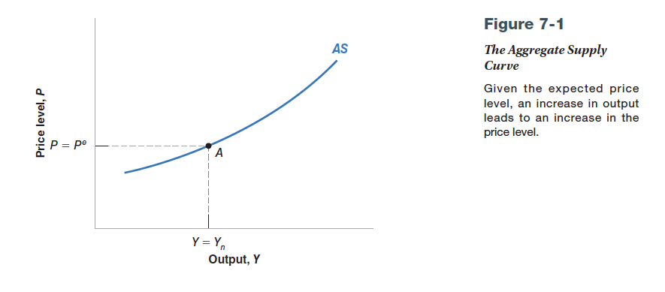**Aggregate Supply**

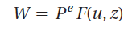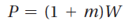 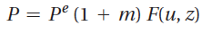 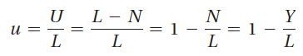

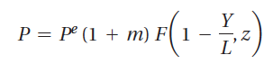

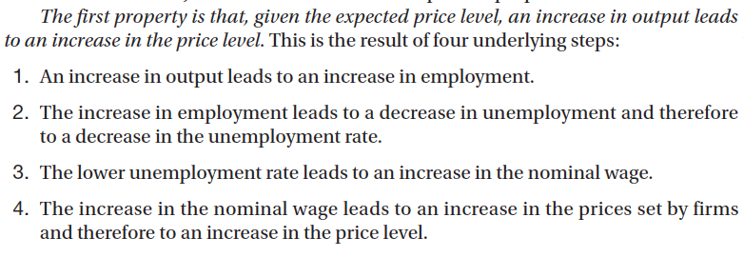

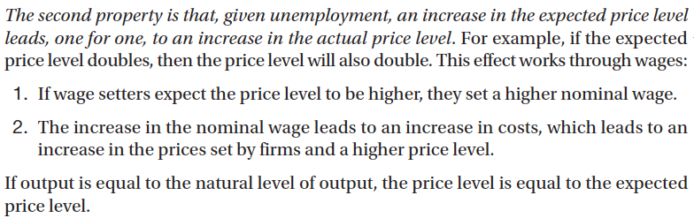

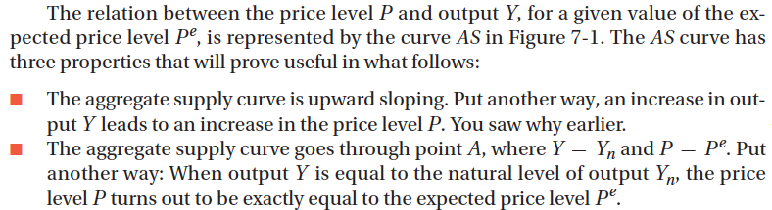

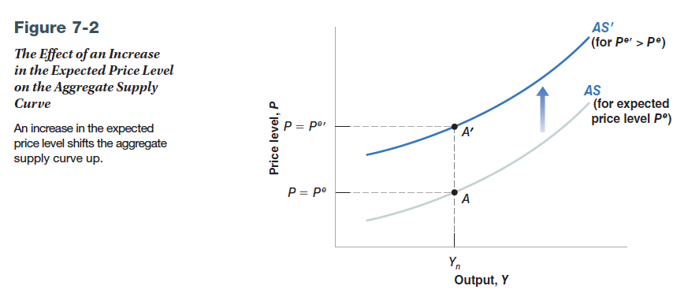

Aggregate Demand

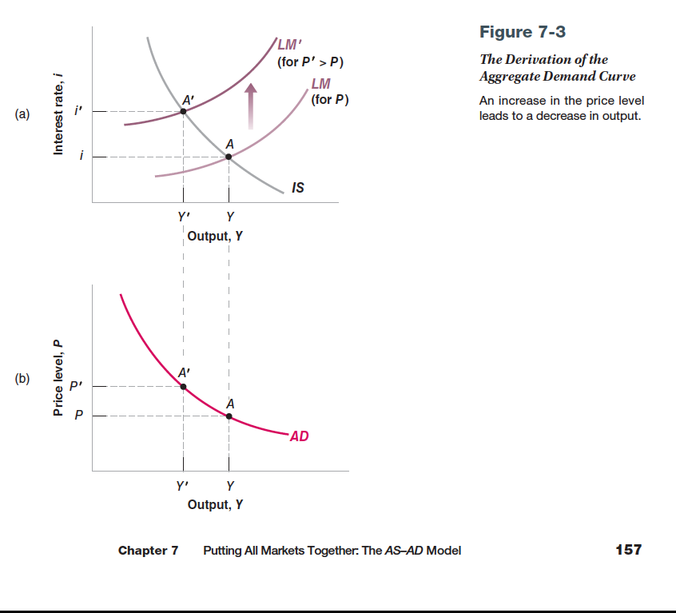

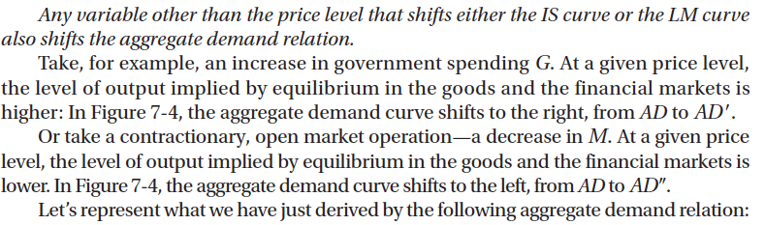

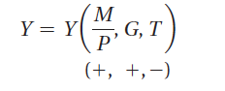

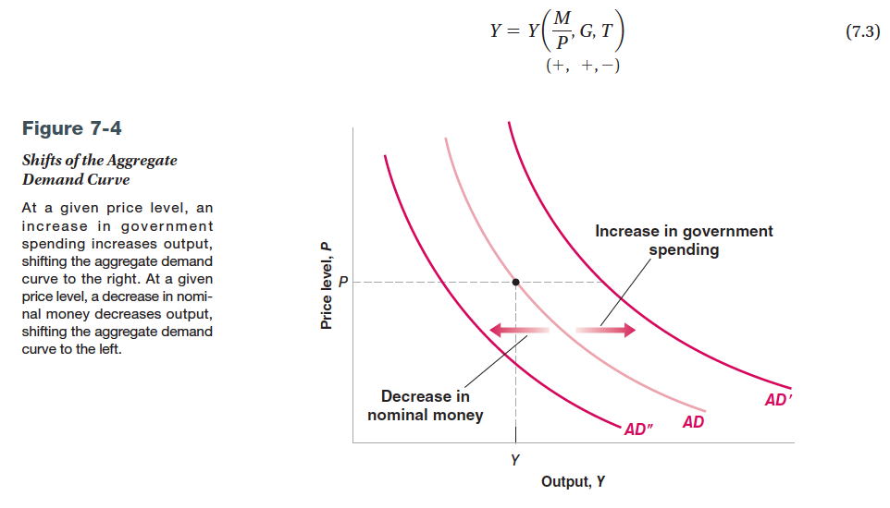

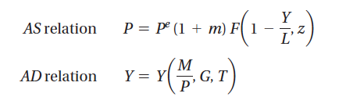

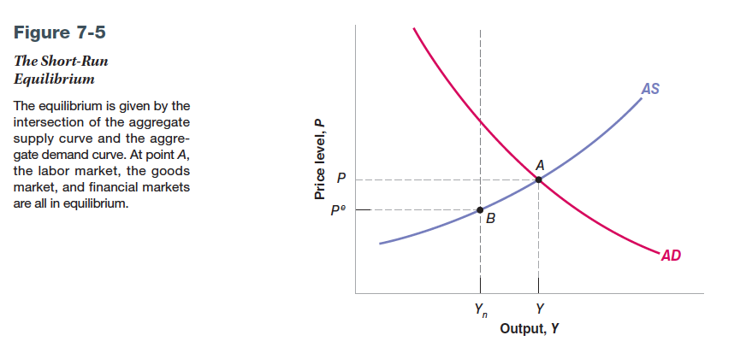

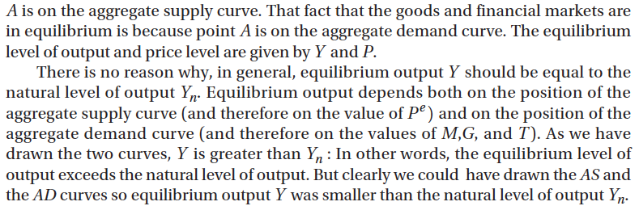

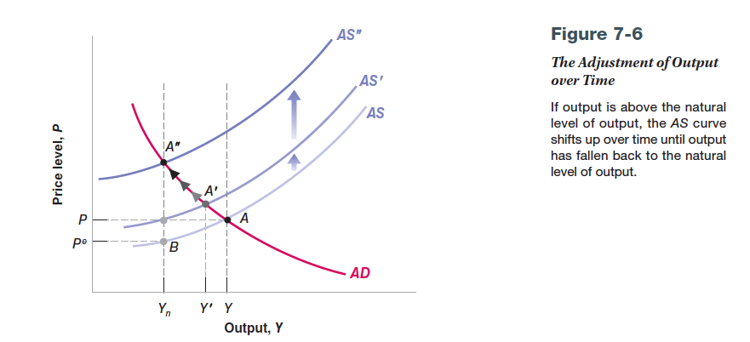

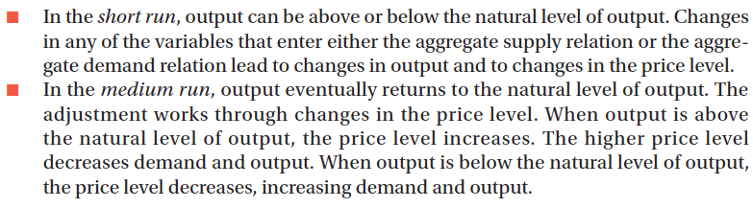

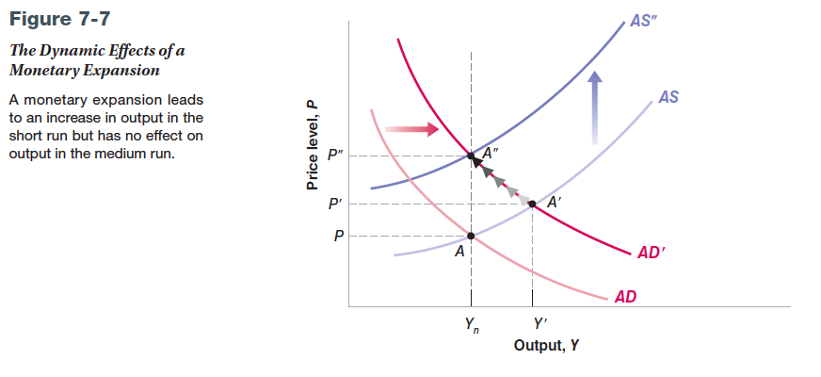

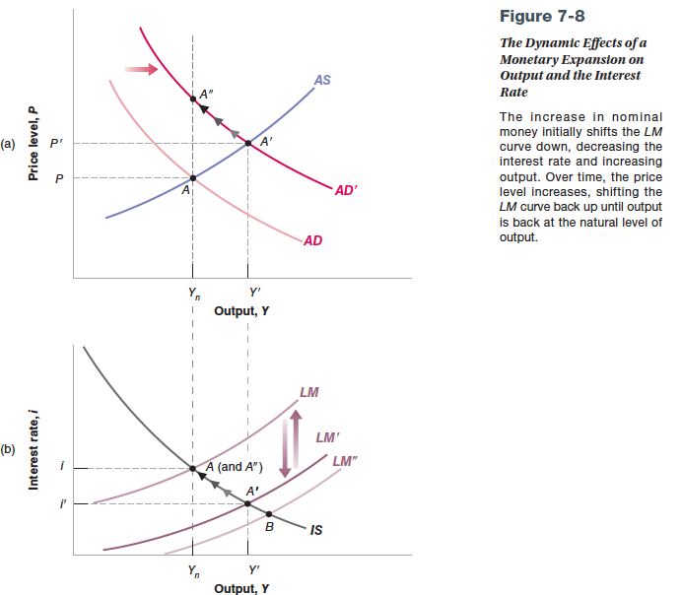

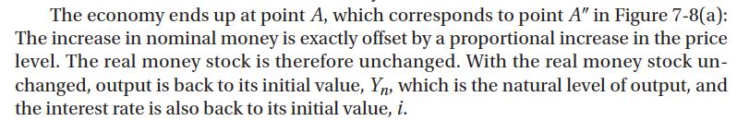

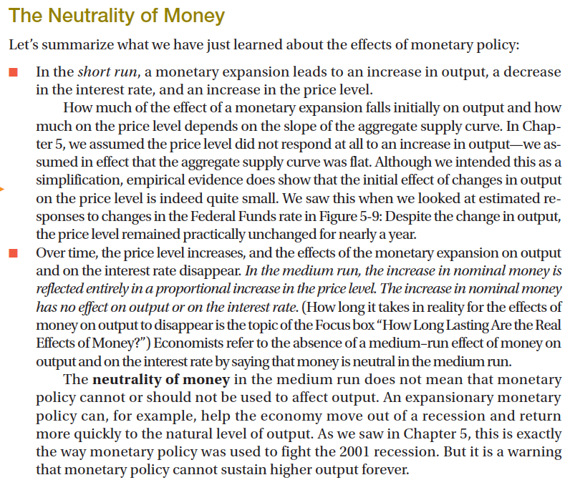

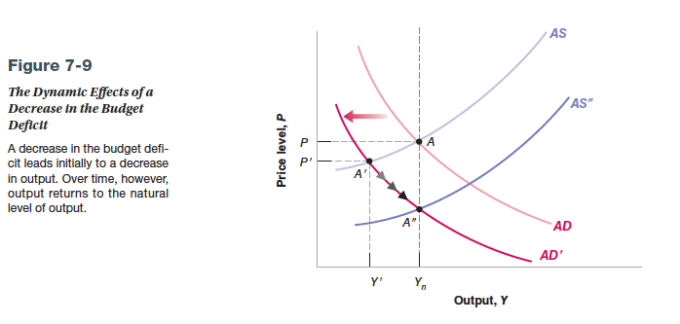

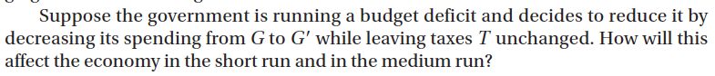

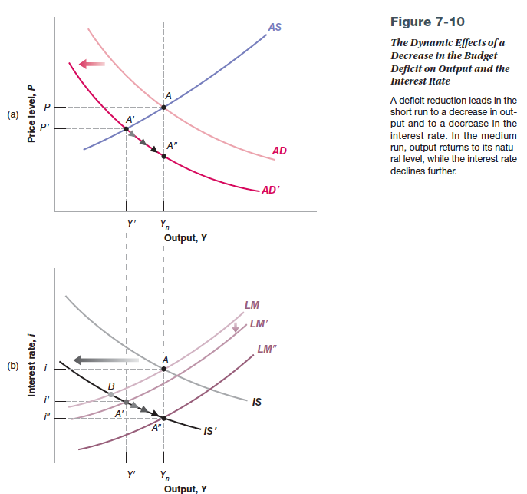

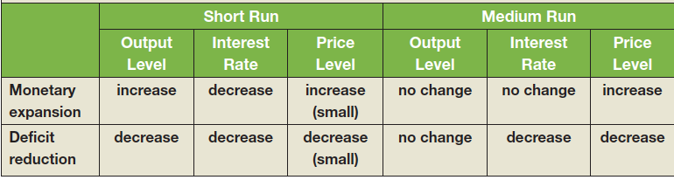





 











**Inflation – Unemployment Relation and Phillips Curve**



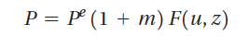

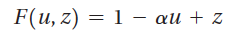

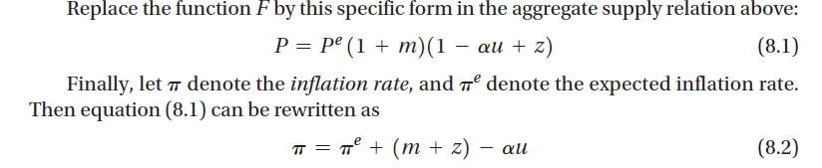

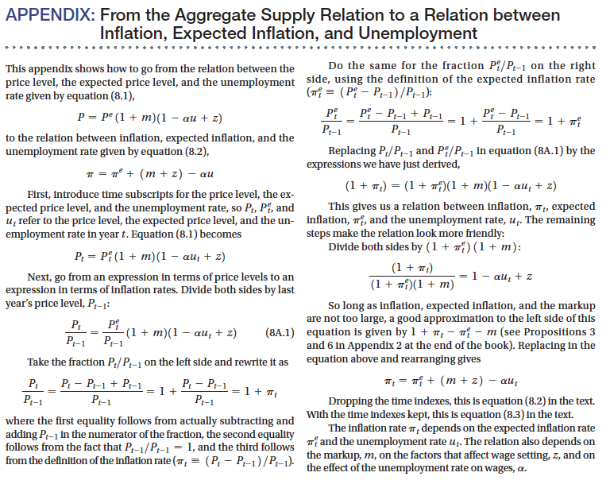



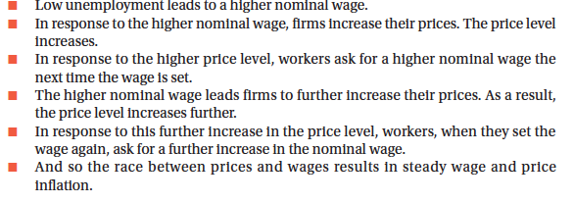

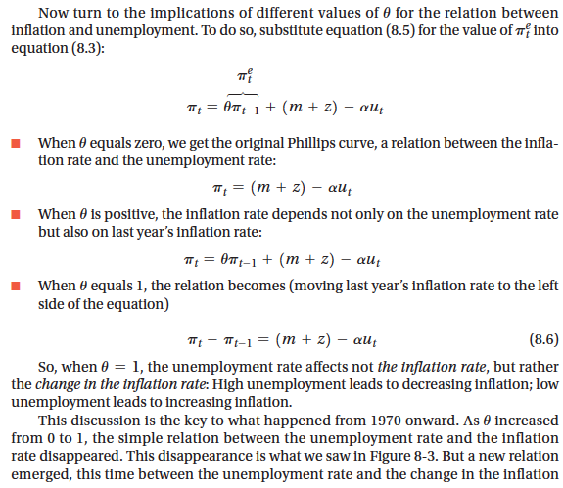

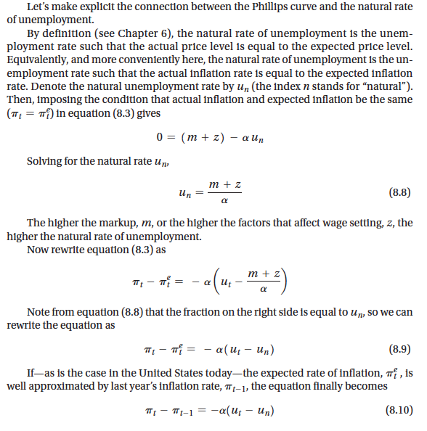

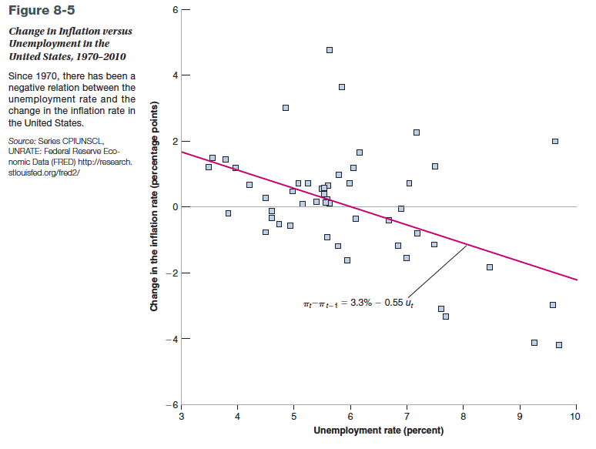







|  |  |  |  |  |
| --- | --- | --- | --- | --- |
| **Okun'sLaw** | **Türkiye** |  | **USA** |  |
|  | **GDP grw** | **unemp rate** | **GDP grw** | **unemp rate** |
| **1980** | -2.78 | 7.88 | -0.2 | 7.2 |
| **1981** | 4.81 | 6.93 | 2.4 | 7.6 |
| **1982** | 3.09 | 6.82 | -2 | 9.7 |
| **1983** | 4.21 | 7.51 | 4.3 | 9.6 |
| **1984** | 7.11 | 7.41 | 7.3 | 7.5 |
| **1985** | 4.30 | 6.95 | 3.8 | 7.2 |
| **1986** | 6.76 | 7.72 | 3.4 | 7 |
| **1987** | 9.81 | 8.13 | 3.4 | 6.2 |
| **1988** | 1.45 | 8.23 | 4.2 | 5.5 |
| **1989** | 1.63 | 8.37 | 3.5 | 5.3 |
| **1990** | 9.37 | 7.81 | 1.8 | 5.6 |
| **1991** | 0.35 | 7.85 | -0.5 | 6.9 |
| **1992** | 6.40 | 8.12 | 3.1 | 7.5 |
| **1993** | 8.14 | 8.51 | 2.7 | 6.9 |
| **1994** | -6.08 | 8.19 | 4 | 6.1 |
| **1995** | 7.95 | 7.31 | 2.7 | 5.6 |
| **1996** | 7.12 | 6.35 | 3.6 | 5.4 |
| **1997** | 8.29 | 6.55 | 4.4 | 4.9 |
| **1998** | 3.86 | 6.67 | 4.3 | 4.5 |
| **1999** | -6.08 | 7.49 | 4.1 | 4.2 |
| **2000** | 6.34 | 6.44 | 3.8 | 4 |
| **2001** | -9.43 | 8.37 | 0.3 | 4.8 |
| **2002** | 7.80 | 9.18 | 2.4 | 5.8 |
| **2003** | 5.50 | 8.55 | 2.6 | 6 |













**The Quantity Theory of Money and Inflation**

**Money Growth – Inflation:**

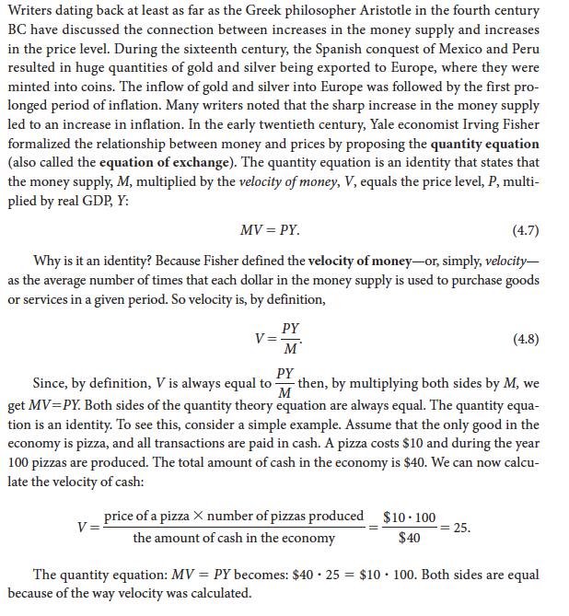

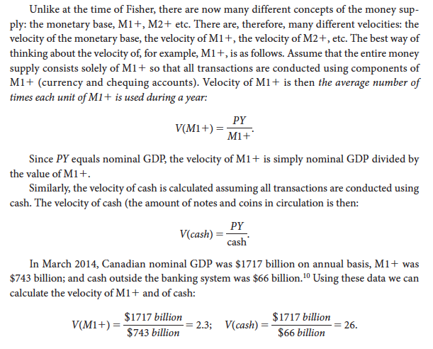

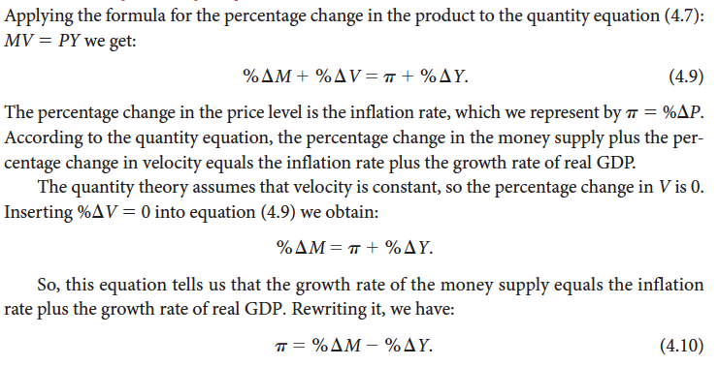

















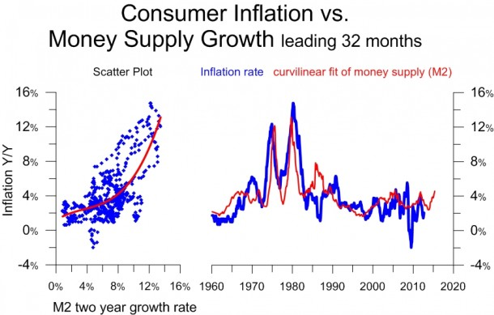

**Velocity of Money and Money Multiplier**

***Why Deflation is Possible***

**APRIL 12, 2010**

By Tim McMahon

In a larger macroeconomic sense, on a nationwide basis if you divide the total Gross Domestic Product (GDP) by the Money Supply (M1) you get the Velocity of Money. As we can see from the following chart the velocity of money climbed steadily from turn over of just above six per year in 1994 through a high of just under 10.5 in 2008.  **As the economy heated up people spent their money faster.**

**Velocity of money refers to how quickly people spend the money they have got. In times of boom and/or inflation, people spend money really quickly.** **At times of recession, people start saving money and don't spend it (look at the graph falls in all shaded regions - during recessions)**.

**During times of high inflation and prosperity people don’t hang on to their money very long, either from fear of it’s losing value** or because they feel rich and think they can spend to their hearts content.

**During periods of recession (the gray bars on the chart) the velocity of money falls as people start saving and conserving**.  There was one break in the steady ascent during the 2001 recession. It is interesting to note that even after the official recession ended in 2002 it took several years before the velocity of money began climbing again. But now we see that people have slowed their purchases as we entered a longer recession and the money’s velocity has once again fallen to about 8.5

**If people are saving more, they are borrowing less and spending less. So all that happens is that people are paying down debt and building their reserves.  This does not “stimulate the economy” or  drive up prices, so it reduces the government’s ability to impact deflation.**

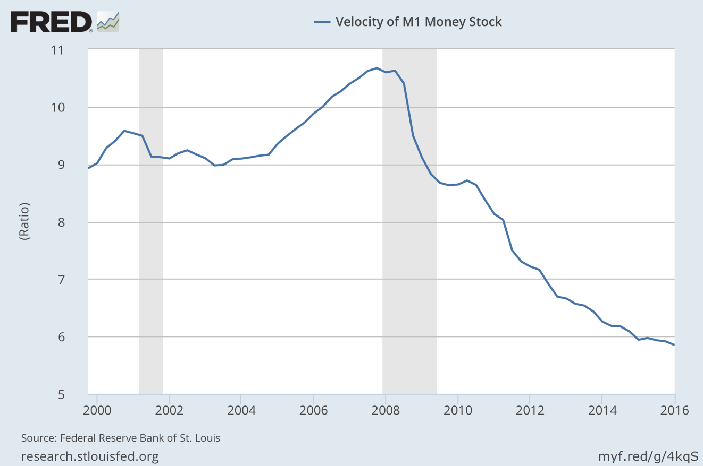

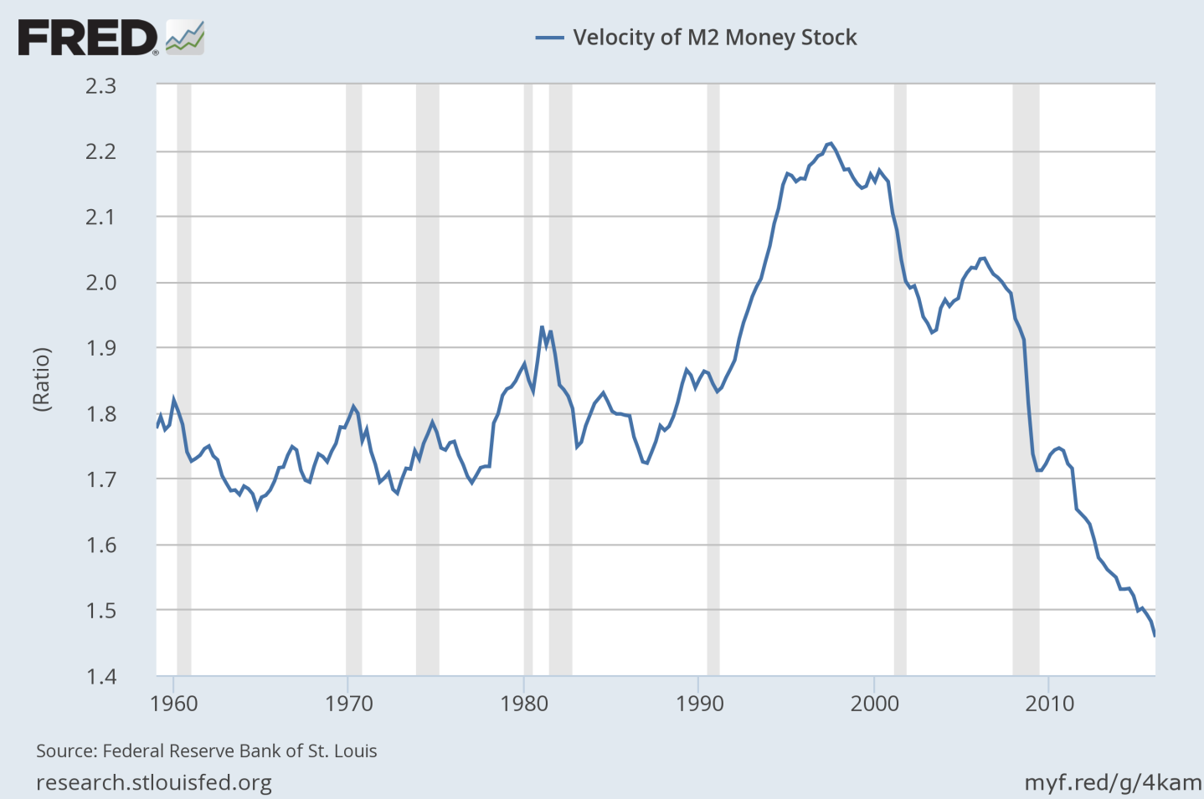

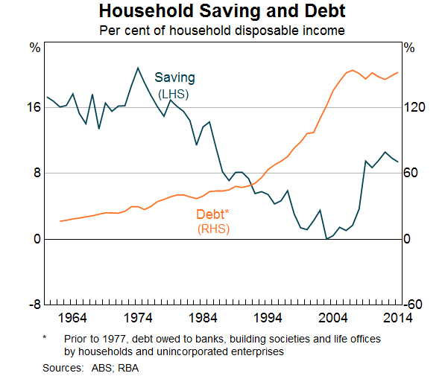

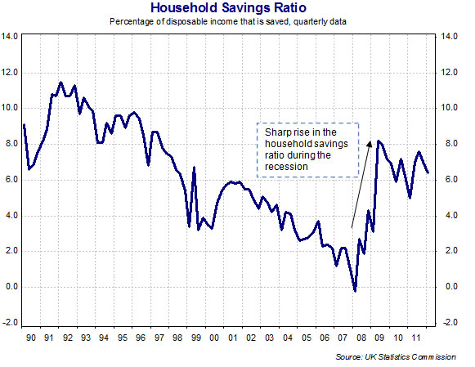

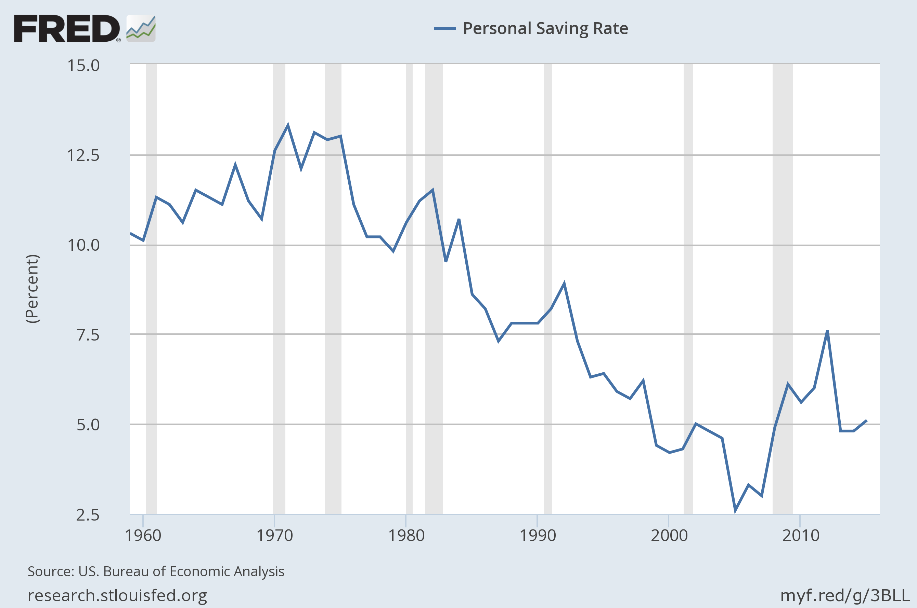

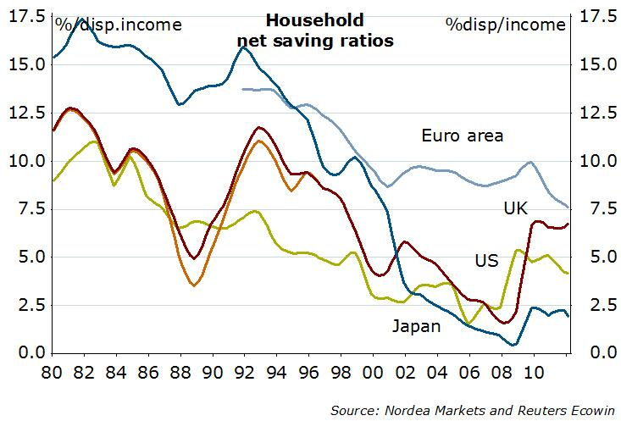

The next factor working against the effectiveness of the government’s fight against deflation is the **money multiplier.**

**But what happens if one (or all) of the banks decides it isn’t prudent to loan out the money and they prefer to increase their reserves instead? In that case the money multiplier falls**.  In the following chart we can see that the M1 money multiplier has actually fallen steadily from just under 1,8x in 2000. But in 2008 the money multiplier plummeted to under 1x.

But if you multiply by less than one, you end up with less than you started with!  In other words, every dollar the government is pumping into the economy is ending up in the banks and going nowhere**!  It is not increasing the money supply, it is not multiplying, it is not creating inflation.  It is going to boost the balance sheets of the banks.**

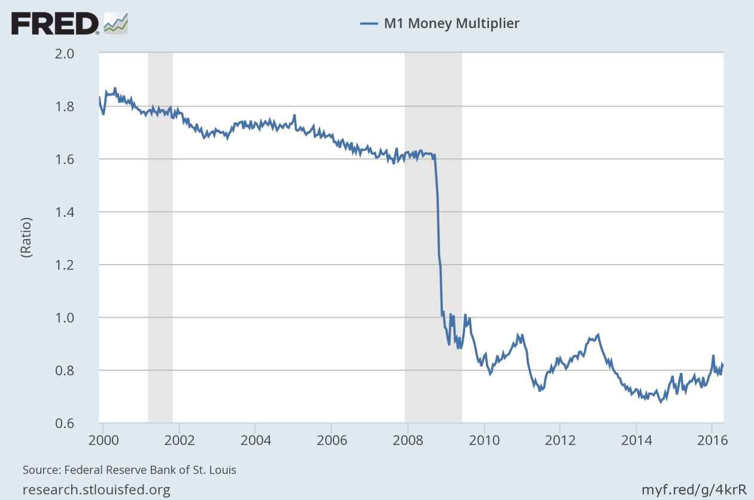

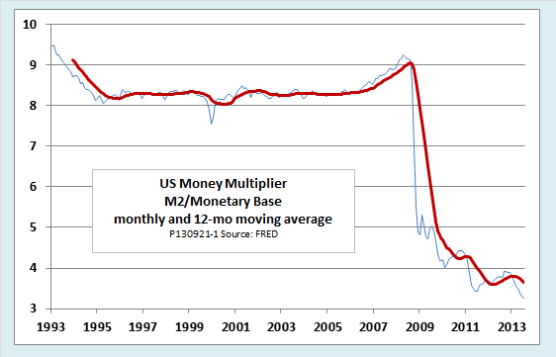

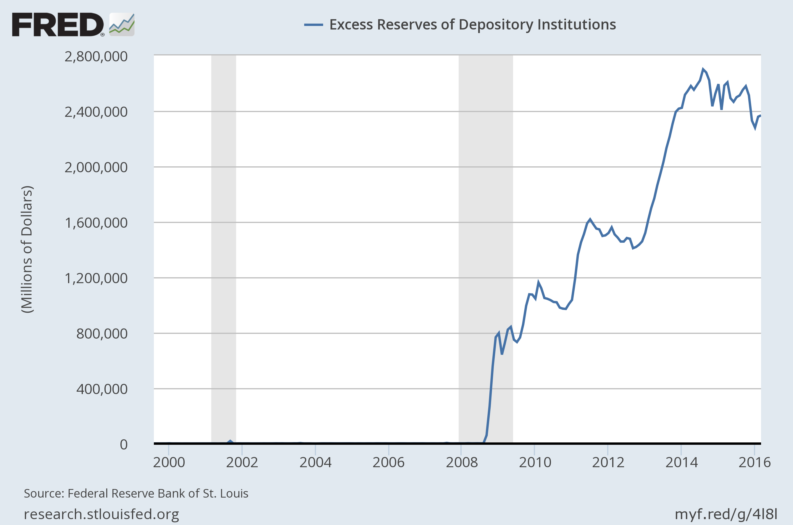

**The combined forces of the velocity of money and the money multiplier are stronger than the government’s printing presses.**

**Quantitative easing** (**QE**) **is a**[**monetary policy**](https://en.wikipedia.org/wiki/Monetary_policy)**used by**[**central banks**](https://en.wikipedia.org/wiki/Central_bank)**to stimulate the economy when standard monetary policy has become ineffective.**  A central bank implements quantitative easing **by buying**[**financial assets**](https://en.wikipedia.org/wiki/Financial_asset)**from** [**commercial banks**](https://en.wikipedia.org/wiki/Bank) and other financial institutions to **increase the**[**money supply**](https://en.wikipedia.org/wiki/Money_supply). This differs from the more usual policy of buying or selling short-term [government bonds](https://en.wikipedia.org/wiki/Government_bond) to keep [interbank interest rates](https://en.wikipedia.org/wiki/Interbank_interest_rate) at a specified target value

Normally, when there's a **recession**, the Federal Reserve will **reduce short-term interest rates in order to spur more lending and spending**. But right now, the Fed has cut interest rates as far as they can go and the economy is still struggling. This is known as the "zero bound." The Fed can't go any lower.

[Expansionary monetary policy](https://en.wikipedia.org/wiki/Expansionary_monetary_policy) to stimulate the economy typically involves the central bank buying short-term government bonds to lower short-term market interest rates. However, **when short-term interest rates reach or approach** [**zero**](https://en.wikipedia.org/wiki/Zero_interest_rate_policy)**, this method can no longer work**.In such circumstances **monetary authorities may then use quantitative easing to further stimulate the economy by buying assets of longer maturity than short-term government bonds.**

**This pumps money into the U.S. economy and reduces long-term interest rates further. When long-term interest rates go down, investors have more incentive to spend their money now.**

**November 2008, after the financial crisis hit, the Fed started buying up mortgage-backed securities and Treasury bills in order to boost the economy. By June of 2010, the bank had bought about $2.1 trillion worth of assets.**

At this point, the Fed halted its actions, figuring that it had done enough. But when the economy started weakening that summer, Bernanke resumed the program in August 2010, buying up Treasury bonds in order to maintain the Fed’s balance sheet. This was known as QE2.

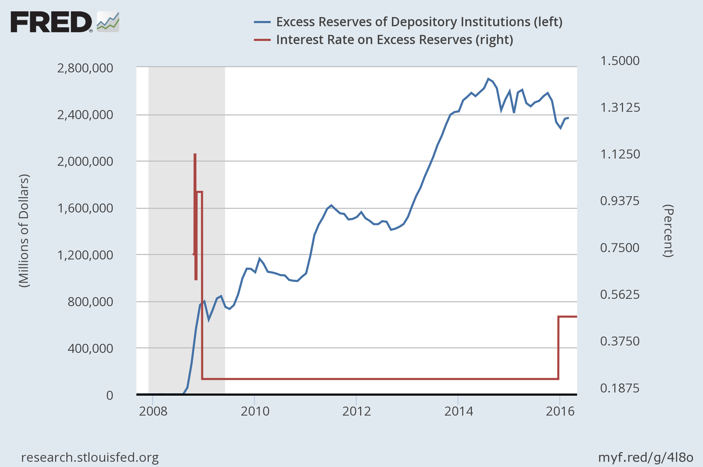

.

## Asset Bubbles

It has been argued that one of the reasons for the housing bubble leading up to the [2008 financial crisis](http://www.investopedia.com/terms/s/subprime-meltdown.asp) was consumers' access to cheap money for mortgages. A buyer of an asset with $2,500 a month of income to finance it can purchase a more expensive asset given a lower interest rate. The ability and incentive to **buy more expensive goods on cheap credit drives up the price of the good and the value of the asset on paper, creating an asset bubble.**

Since 2009, QE efforts have been correlated highly with the bull market in stocks as well as other asset classes. The chart below shows the price of the S&P 500 plotted against the size of the Fed's balance sheet, which gets larger as quantitative easing adds more securities to its books.

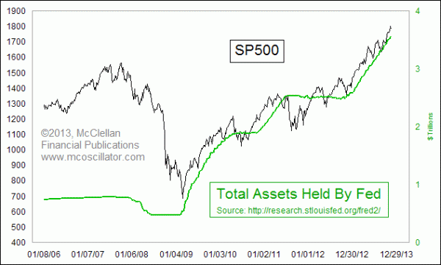





**Will the Fed’s QE strategy lead to inflation?***In the short-term, no.* ***The money multiplier is falling because the economy is in a nasty recession alongside a serious credit crisis. In this environment, the surge of high powered money will not cause prices to rise.***

*Prices normally drop in a recession (deflation) because the demand for money (the ability to purchase goods and services) falls with rising unemployment and declining income (slackening demand for goods and services). But the 2008 recession is accompanied (or partially caused) by a* ***credit crisis that induces banks to hoard the new base as excess reserves****; this adds to the deflationary pressures.*

*If deflation were to become embedded into consumer and firm expectations, then the macroeconomy could be facing a severe problem. So for now, and until the economy emerges from its recession,* ***QE will not lead to inflation***

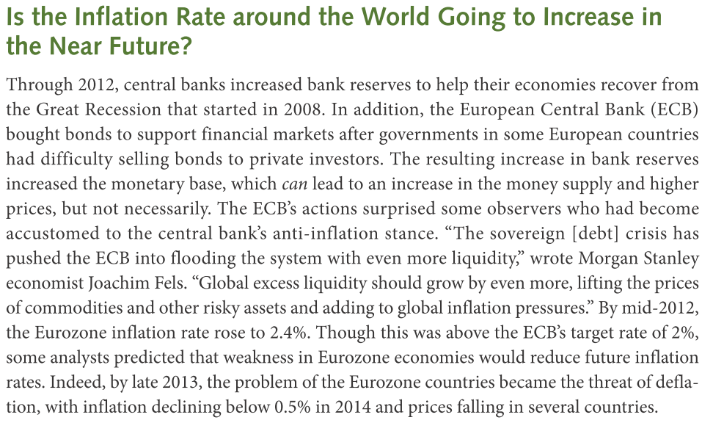

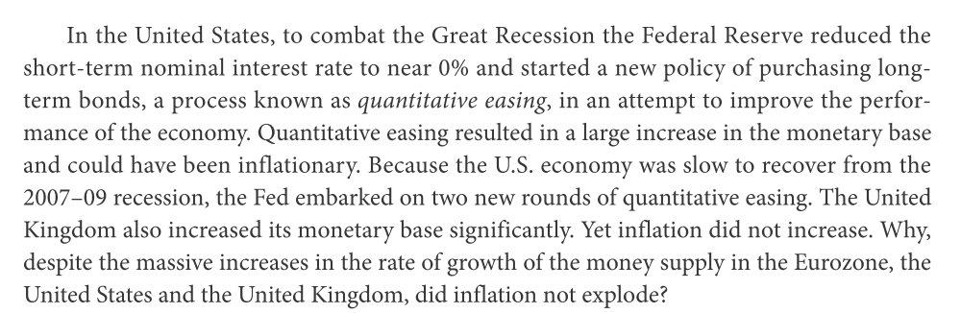

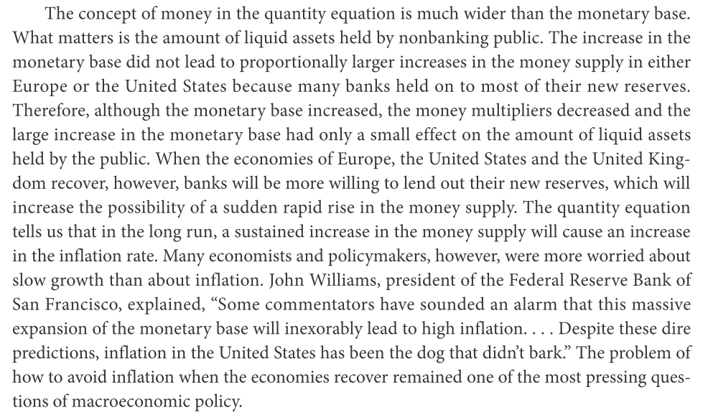

**Budget Deficit 🡺 Money Gowth 🡺 Inflation**

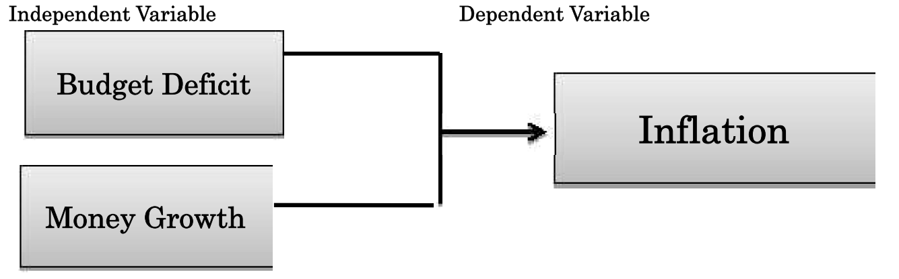

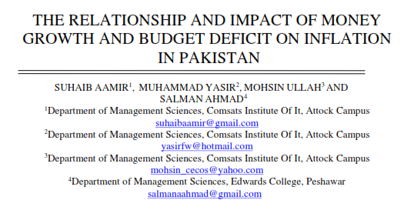Many economists argue that inflation is strictly a monetary phenomenon and that **inflation occurs when the rate of growth of the money supply is higher than the growth rate of the economy.**

Many economic theories and economists emphasize that **budget deficits affect inflation through money supply** and deficit financing channels.

**The Keynesian view suggests that government budget deficits are inflationary because they stimulate aggregate demand**.

**The Monetarist view suggests that government budget deficits are inflationary because they lead to higher money growth.**



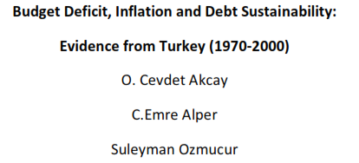It is explained that budget deficits lead to inflation through two financing channels. **The central bank may finance a budget deficit by money creation** (money printing) **or by borrowing** (bond financing). The nominal one-period intertemporal government budget deficit can be written as:



: total stock of government debt.

: nominal interest on government debt.

Also domestic borrowings of the government leads to higher interest rates, it tends to **crowd out** private investments, reduce the growth rate of real output, and increase prices. Higher deficit policies may, however lead to higher inflation even in the absence of monetization by Central banks.

The governments borrowing requirement will increase the net credit demands in the economy, drive up the interest rates and crowd out private investment.

A budget deficit has to be financed, the issue of new government debt bonds to domestic or overseas investors can do this. But government may have to offer higher interest rates to attract buyers of government debt.

In the long run, **higher government borrowing** today may mean that taxes will  have to rise in the future and this would put a squeeze on spending by private sector businesses and millions of households.

Furthermore, many researchers theorize that **money printing** and **domestic market borrowings** are positively related to inflation.

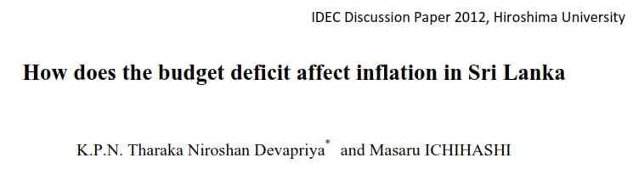

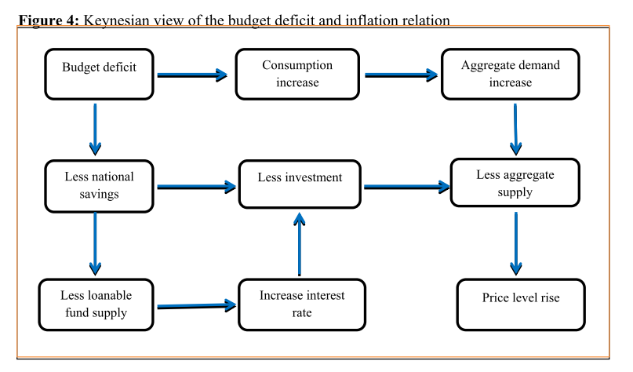

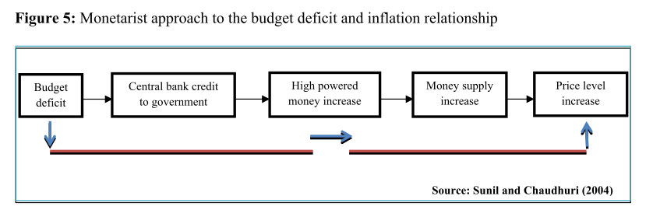

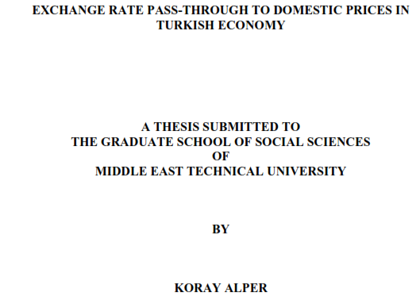**Exchange Rate Pass Through**

Exchange rate pass-through also refers to the effects of exchange rates on domestic inflation

In an open economy one can talk about basically three transmission channels from exchange rates to prices:

1. Prices of traded final goods,
2. Imported intermediate goods,
3. Impact on inflation expectations.

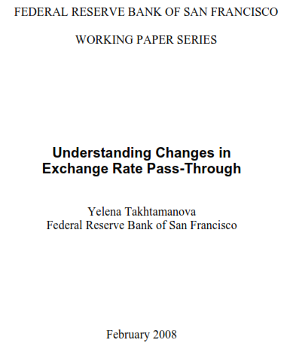

Prices of imported final goods are directly included in Consumer Price Index (CPI). Any fluctuation in the exchange rates affects the prices of the imported final goods which are directly included in CPI. Exchange rate changes are usually perceived as cost shocks for a foreign firm producing outside the destination country and selling in its export market. However, observations show that the firms may not choose to pass the cost shock fully into its selling prices.

Dornbusch (1987) has explained incomplete pass-through via models introducing the degree of market concentration; extent of product homogeneity and the relative market shares of domestic and foreign firms. He shows that if there is oligopolistic competition, and/or import and domestic goods are imperfect substitutes, exchange rate pass-through can be less than unity as firms strategically modify their pricing behavior and consumers change their pattern of consumption to increase or decrease imported goods.

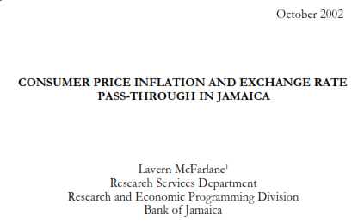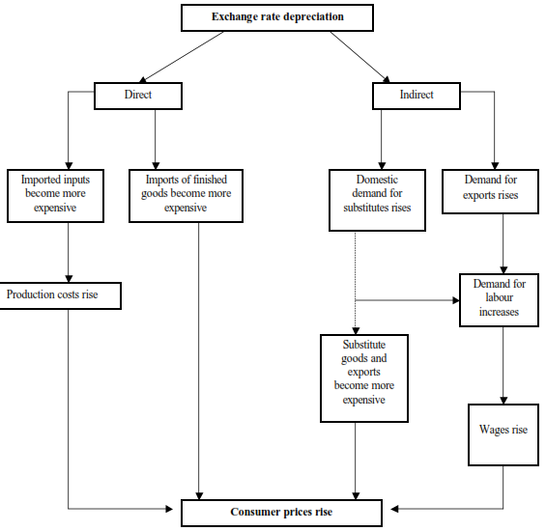

The *indirect* channel of exchange rate pass-through arises because of the impact on aggregate demand. A **depreciation of the exchange rate makes domestic products relatively cheaper for foreign consumers**, **and as a consequence exports and aggregate demand will rise relative to potential output, inducing an increase in the domestic price level**. Since nominal wagecontracts are fixed in the short run, real wages will decrease and output will eventuallyincrease. However, when real wages return to their original level over time, production coststhen increases, the overall price level increases and output falls. Thus, in the end theexchange rate depreciation leaves a **permanent increase in the price** level with only a **temporary increase in output**

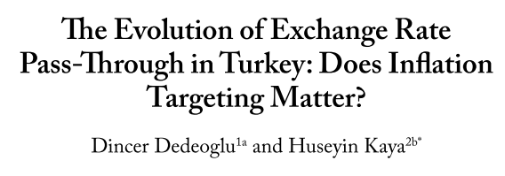

The degree to which changes in the exchange rate are reflected in domestic prices which is known as the exchange rate pass through (ERPT) and it is important for several reasons. For example, the implementation of monetary policy in response to inflationary exchangerate shocks requires information about both the degree and the speed of pass-through of exchange rate to domestic prices.

Exchange rate pass-through also refers to the effects of exchange rates on domestic inflation.

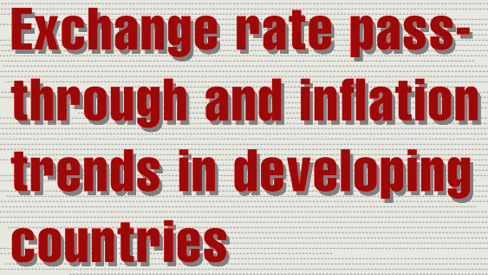

Two episodes of global financial turbulence over the past 13 months saw capital flows decelerate and a number of developing-country currencies depreciate. In parallel, developing-country inflation remained elevated, on average, increasing to 7.4 percent in 2013, up from 6.4 percent in 2012 and an average of 6 percent over the last decade.

The **persistence of high inflation** in an environment characterized by stable or even declining commodity prices reflects a variety of influences, including supply side bottlenecks, country-specific developments and, in the most recent period, **adjustments to past exchange rate depreciations**.

This special topic analyzes the link between currency and inflation patterns across developing economies, based on estimates of the size and timing of the **exchange rate pass-through** in 45 middle and low income countries. It breaks out the relative contribution of exchange rate movements and domestic cyclical conditions to recent inflation trends and presents inflation projections for 2014 and 2015.

The analysis concludes that **currency-related price pressures are mainly concentrated in a few large middle income economies, including Argentina, Venezuela, Turkey, Ghana, South Africa, Indonesia or India.**

**Open Economy Phillips Curve:**

**Phillips Equation Included Exchange Rate Pass Through**

**In open economies, exchange rate fluctuations affect the behavior of inflation**. This makes the exchange rate pass-through (defined as the effect of exchange rate changes on domestic inflation) an important consideration with respect to monetary policy. Several authors claim that even considerably large changes in exchange rates during the 1990s had a surprisingly weak effect on domestic inflation in some small open economies.

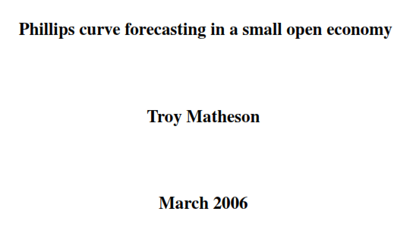 In an open economy, inﬂation is not only determined by domestic economic conditions but also by developments amongst the economy’s trading partners, which inﬂuence the competitiveness of the tradable sector. The closed economy Phillips curve is thus typically augmented with variables that capture the impact of swings in international competitiveness. The simplest way to do this is by including nominal exchange rate terms into equation. Capturing the impact of deviations in international prices suggests the following open economy analogue to the closed economy Phillips curve:



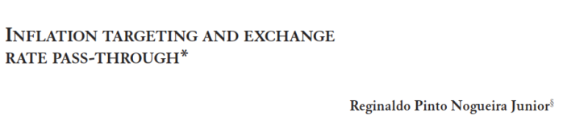 The coefficient   thus measures ERPT Various studies have shown that ERPT has declined in recent years, particularly in developed economies. As this decline has coincided with significant falls in the level of inflation, researchers have examined whether the degree of ERPT is related to the inflation environment.

It is possible to express expected inflation related with credit growth rate ( )





1. When people decide whether to hold money or bonds, they take into account the opportunity cost of holding money rather than bonds—the **opportunity cost** is what they give up by holding money rather than bonds. Money pays a zero nominal interest rate. Bonds pay a nominal interest rate of *i*. Hence, the opportunity cost of holding money is equal to the difference between the interest rate from holding bonds minus the interest from holding money, so *i* - 0 = *i*, which is just the nominal interest rate . Therefore, the *LM* relation is still given by (Blanchard and Johnson, 2013:317)

   The money you hold in your wallet does not earn interest. If, instead of holding that money, you used it to buy government bonds or deposited it in a saving saccount, you would earn the nominal interest rate. Therefore, the nominal interest rate is the **opportunity cost** of holding money: it is what you give up by holding money rather than bonds (Mankiw, 2015: 118).